SIMATS ENGINEERING
ASSESSMENT TOOL 1

COURSE CODE: CSA14
COURSE NAME: COMPILER DESIGN
Code of Conduct:
I Sarika K S (192521039)certify that this submission is my original
work and that I have adhered to the guidelines specified for this assessment.
I understand that any violation of academic integrity rules will result in disciplinary
EXPERIMENTS
Q1.You are developing a compiler-based desk calculator that evaluates arithmetic
expressions using syntax-directed definitions (SDD).
The system should:
(i) Accept an arithmetic expression with operators +, -, *, / and parentheses
(ii) Use syntax-directed evaluation to compute values based on operator precedence
(iii) Optimize evaluation by reducing unnecessary temporary computations
(iv) Display the final result of the expression
Demonstrate how SDD rules (synthesized attributes) are used for expression
evaluation.
SDD
Grammar with semantic rules:
E → E + T { E.val = E1.val + T.val }
E → E - T { E.val = E1.val - T.val }
E → T { E.val = T.val }
T → T * F { T.val = T1.val * F.val }
T → T / F { T.val = T1.val / F.val }
T → F { T.val = F.val }
F → (E) { F.val = E.val }
F → digit { F.val = digit }
Aim
To evaluate arithmetic expressions using Syntax-Directed Definitions (SDD) with synthesized attributes while following operator precedence and minimizing unnecessary temporary computations.

PROGRAM:
#include <stdio.h>
int main() {
int a, b, c;
char op1, op2;
printf("Enter expression (Example: 3+4*5): ");
scanf("%d%c%d%c%d", &a, &op1, &b, &op2, &c);
int result;
if ((op2 == '*' || op2 == '/') && (op1 == '+' || op1 == '-')) {
int temp;
if (op2 == '*')
temp = b * c;
else
temp = b / c;
if (op1 == '+')
result = a + temp;
else
result = a - temp;
} else {
int temp;
if (op1 == '+')
temp = a + b;
else if (op1 == '-')
temp = a - b;
else if (op1 == '*')
temp = a * b;
else
temp = a / b;
if (op2 == '+')
result = temp + c;
else if (op2 == '-')
result = temp - c;
else if (op2 == '*')
result = temp * c;
else
result = temp / c;
}
printf("Result = %d\n", result);

return 0;
}
OUTPUT:
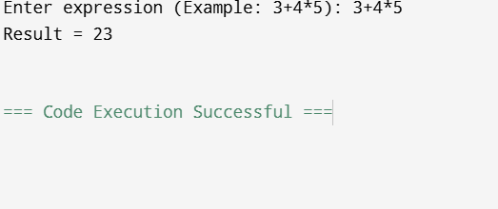

Q2. In a compiler, postfix expressions are evaluated during code generation using
stack-based bottom-up evaluation.
Write a C program that:
(i) Evaluates a postfix expression
(ii) Demonstrates S-attributed definition evaluation
(iii) Shows how intermediate results are computed
Aim
To develop a C program for evaluating a postfix expression using a stack-based bottom-up evaluation, demonstrating S-attributed definition (Syntax-Directed Definition) and showing the computation of intermediate results during expression evaluation.
PROGRAM
#include <stdio.h>
#include <ctype.h>
int stack[100];
int top = -1;
void push(int x) {
stack[++top] = x;
}
int pop() {
return stack[top--];
}
int main() {
char postfix[100];
int i, a, b, result;
printf("Enter Postfix Expression: ");
scanf("%s", postfix);
for (i = 0; postfix[i] != '\0'; i++) {
if (isdigit(postfix[i])) {
push(postfix[i] - '0');
} else {
b = pop();
a = pop();
switch (postfix[i]) {
case '+':
result = a + b;
break;
case '-':
result = a - b;
break;
case '*':
result = a * b;
break;
case '/':
result = a / b;
break;
}
printf("%d %c %d = %d\n", a, postfix[i], b, result);
push(result);
}
}
printf("Final Result = %d\n", pop());
return 0;
}

OUTPUT
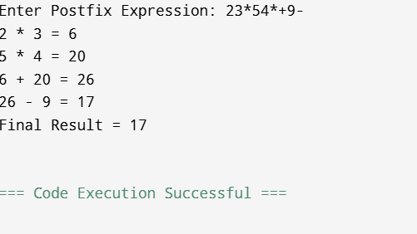
Q3 In a compiler, it is important to check whether two type expressions are
equivalent.
Write a C program that:
(i).Accepts two type expressions (e.g., int, float, int*)
(ii).Compares them for type equivalence
(iii).Displays whether they are:
(a).Equivalent
(b).Not equivalent
Extend the logic to handle pointer types (int*, float*).
Aim
To develop a C program that accepts two type expressions, compares them for type equivalence, and displays whether they are equivalent or not equivalent, including support for pointer types such as int* and float*

PROGRAM
#include <stdio.h>
#include <string.h>
int main() {
char type1[20], type2[20];
printf("Enter first type: ");
scanf("%s", type1);
printf("Enter second type: ");
scanf("%s", type2);
if (strcmp(type1, type2) == 0)
printf("Equivalent Types\n");
else
printf("Not Equivalent Types\n");
return 0;
}

OUTPUT

